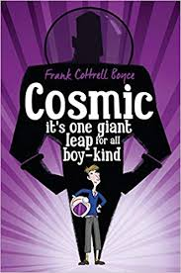Cosmic

By Frank Cottrell Boyce

Cosmic was a very fun book .This book is about a boy Called Liam, who was not like any other teenager .He Was Very tall for a 12 year old and grew Facial hair .He didn’t have any friends in life but he has Friends on his computer. One day a company called if he wanted to go to China to the new theme park.

Street child

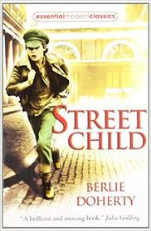By Berlie Doherty

This book is about a boy called Jim who lost his Mother, His sisters and his Father. And had to work at the workhouse for 5 years. Then he wanted to escape which was a success. But then Grimy Nick bought him from his Mothers Friend`s Grandfather and made Jim work for 12 hours a day.

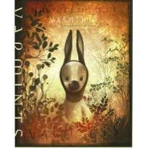Varmint

By Helen Ward

We haven’t started reading it yet but we have watched the trailer. And we as a class think it is going to be a interesting and adventures book.

Watch the trailer by clicking the link

<https://vimeo.com/ondemand/2145/45710839>