English

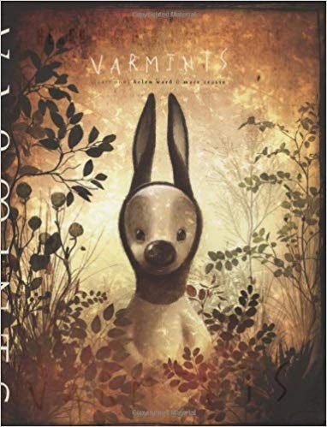In English this week, we have been learning on how the words effect the reader. The book we have been looking at is Varmints. So far, we have made a mind bubble on how the varmints act, eat, live and behave. Then we did a poster on a warning of the varmints and what they will do. Here is the cover of the book.

My opinion of the trailer is that it was very dark and gloomy. My favourite part is when the main character found the flower.

Opinion By: Charlie

Presented By: Jada