Alicia has a bag of 6 sweets. Anna gives her one more. How many does Alicia now have?   | Alicia has 5 bars of chocolate.  She gives 1 bar to Will. How many does Alicia have left?  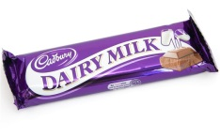
Alicia has 4 pens in her pencil case. Miss Stevens takes one of them to use. How many does Alicia have left?  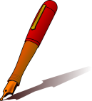 | Alicia has 3 gold stars for good effort. Miss Stevens gives her 1 more. How many does Alicia have now?  
Alicia loves cakes. She buys 9 cakes. Alicia’s friend Emily eats one of them! How many are left?  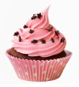 | Alicia holds up 5 fingers. Then she puts 1 finger down. How many is she now holding up?  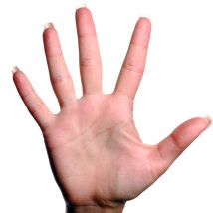
Alicia has 8 coins in her purse. Her Mum gives her one more coin. How many does Alicia have now?  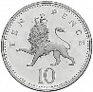 | Alicia has 7 chocolates hanging on the Christmas tree. She eats 1 of them. How many are now left?  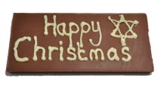
Alicia has 10 jelly sweets. She eats 1. How many are left?
