Green
There were 4 blue birds and 4 yellow birds.
Complete the 8 number sentences
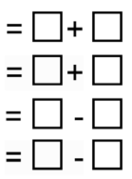
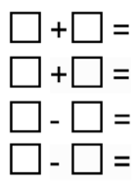

Green
There are 4 yellow hats and 5 red hats.
Complete the 8 number sentences.

Green
There were 9 footballs and 8 were kicked away.
Complete the 4 number sentences.

