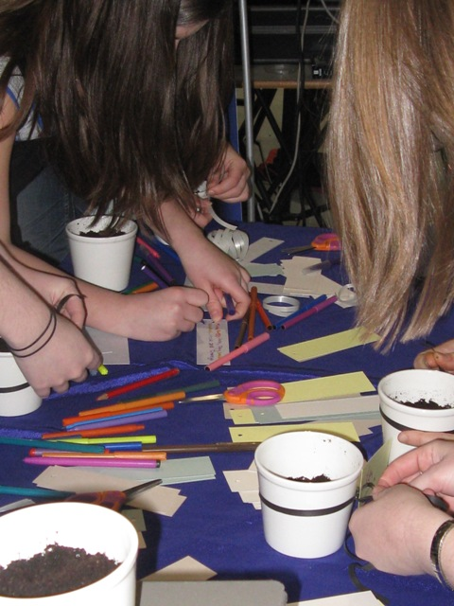
Good Morning, dear Jesus,

I give You this day,

My soul and my body,

My work and my play.

All for You, dear Jesus,

All for you this day,

Amen

